

2023下



All Copyrights reserved

请打印听课

四六级我只看瑞斯拜

where there is a will, there is a way.

**我是瑞斯拜四级**

**听力**

课程观看B站：我是瑞斯拜

写在前面

亲爱的同学，听力是一项输入性的技能。除了需要一定词汇基础之外，对基本的语音现象也有所了解。如连读，弱读，吞音这类的现象。这在我的课程中均会讲解。你不必每个语音现象都听出来，但是了解这些现象对你的听力口语提高很有帮助。 在四六级考试中听力占分较高，为总分的35%。但是想要及格却不是特别难，在课程中会给大家讲解基本的做题方法，听力选项的技巧，以及复习策略。 大家在学会方法后考试前刷至少10套以上真题，这样听力才会比较稳定能及格。如果听完课还觉得不够的话可以参考往年课程，都在我的B站收藏有合集。方法都一样，选取的例题不一样。

总之大家有任何问题都可以在评论区留言，或者在B站直接@我，我在录课的空余会抽空解答大家的问题的。

**Section** **A 题型1 新闻报道**

**Directions:** In this section, you will hear three news reports.At the end of each news report, you will hear two or three questions. Both the news report and the questions will be spoken only once.Affer you hear a question, you must choose the best answer from the four choices marked A),B),C) and D).Then mark the corresponding letter on **Answer** **Sheet** **1** with a single line through the centre.

**Questions** **1** **and** **2** **are** **based** **on** **the** **news** **report** **you** **have** **just** **heard.**

|  |  |
| --- | --- |
| 1.A) A free car show.  B) A yearly concert.  2.A) Improve the image of Glasgow city.  B) Enrich the local culture of Glasgow. | 1. A sports competition. 2. A pipe band contest. 3. Contribute a lot to the local economy. 4. Entertain people in local communities. |



**Questions** **3** **and** **4** **are** **based** **on** **the** **news** **report** **you** **have** **just** **heard.**

|  |  |
| --- | --- |
| 3.A) Surprising rise in global sea levels.  B) Dangerous ice melts in Greenland.  4.A) It began in late May.  B) It lasted three months. | 1. Changing weather patterns in summer. 2. Record growth of Greenland5s ice sheets. 3. It started a month earlier than usual. 4. It ended a month earlier than before. |

**Questions5to7are** **based** **on** **the** **news** **report** **you** **have** **just** **heard.**

5. A) Bundles of £ 20 notes kept turning up.

B)A villager was searching for his lost cash.

C)Local policemen came across bundles of £ 20 notes.

D)A bundle containing thousands of pounds got stolen.

|  |  |
| --- | --- |
| 6.A) They give it to charity.  B) They return it to the finder.  7.A) They cooperated well with the police.  B) They enjoyed a fairly affluent life. | C)They hand it over to the local government.  D)They place a notice in *The Northern Echo.*  C)They were puzzled by the mystery.  D)They had a strong community spirit. |



**Section** **B 题型2 长对话**

**Directions:** In this section, you will hear two long conversations.At the end of each conversation, you will hear four questions. Both the conversation and the questions will be spoken only once.Afier you hear a question, you must choose the best answer from the four choices marked A), B),C)and D). Then mark the corresponding letter on!**Answer** **Sheet** **1** with a single line through the centre.

**Questions8** **to** **11** **are** **based** **on** **the** **conversation** **you** **have** **just** **heard.**

8.A) Excited. C) Indifferent.

B)Delighted. D) Strange.

9.A) Search for the meaning of their life. C) Call on their relatives and friends.

B)Look back on their years at school. D) Talk about future plans with friends.

10.A) He prefers to have them shown on social media.

B)He loves them but does not want to make a fuss.

C)He enjoys celebrating others’ birthdays rather than his own.

D)He looks forward to receiving presents from his close friends.

11.A) Hold it on a modest scale to remove birthday anxieties.

B)View it as a chance for people to socialize and have fun.

C)Extend invitation to those he trusts most.

D)Make it an occasion to collect donations.



**Questions** **12** **to** **15** **are** **based** **on** **the** **conversation** **you** **have** **just** **heard.**

|  |  |
| --- | --- |
| 1. A) It was absolutely exhausting.   B) There was a terrible smell.   1. A) She hasn't saved enough money.   B) She is worried about traffic jams.   1. A) They are popular.   B) They are dangerous.   1. A) By bus.   B) By jogging. | 1. There was too long a delay. 2. She got off at the wrong station. 3. She hasn't passed the driving test yet. 4. She is used to taking public transport. 5. They are a bit expensive for her. 6. They are environmentally friendly. 7. By renting a bike. 8. By sharing a ride. |



**Section C 题型3 篇章**

**Directions:** In this section, you will hear three passages At the end of each passage,you will

hear three or four questions.Both the passage and the questions will be spoken only once.

After you hear a question,you must choose the best answer from the four choices marked A), B), C)and D).Then mark the corresponding letter on **Answer Sheet 1** with a single line through the centre.

Questions 16 to 18 are based on the passage you have just heard.

|  |  |
| --- | --- |
| 16.A) He is a sign language interpreter.  B) He is a deaf person working in IT.  17.A) Improved communication skills.  B) Speech recognition technology.  18.A) He can avoid being mistaken.  B) He can take notes on the spot. | C)He doesn't like speaking at meetings.  D)He doesn't use email or text messages.  C)Big advances in sign language.  D)Transformation in the IT industry.  C)He can understand with ease.  D)He can see the speakers’ images. |

n.

**Questions** **19** **to** **21** **are** **based** **on** **the** **passage** **you** **have** **just** **heard.**

19.A) To find pure white walls shining. C) To get a hug from family members.

B)To enter a house well looked after. D) To see cheerful colours all around.

20.A) Choosing a colour because it is fashionable.

B)Painting the interior of their cupboards.

C)Doing the painting job all by themselves.

D)Designing all window frames the same way.

21.A) Fit most of the cupboards into walls.

B)Hang landscape paintings all around.

C)Match the room's ceiling with all the furniture in colour.

D)Paint the wooden frameworks and walls the same colour.

**Questions** **22** **to** **25** **are** **based** **on** **the** **passage** **you** **have** **just** **heard.**

22.A) Children must read at least 3 times a week.

B)Reading is a habit every child can develop.

C)Reading to their children is important.

D)Children should start reading at age 3.

23.A) The number of books they have read by age four.

B)The speed of their brain development in infancy.

C)The number and quality of books parents read to them in infancy.

D)The quality and quantity of time parents spend playing with them.

24.A) Books with specifically labeled images. C) Books describing the lives of animals.

B) Books with pictures of dolls and toys. D) Books telling very interesting stories.

25.A) Read as many books as possible to their children.

B)Choose carefully what to read to their children.

C)Share experience with other parents.

D)Create picture books for their children.

|  |
| --- |
|  |
|  |
|  |
|  |
|  |

**Section** **A**

**Questions** **1** **and** **2** **are** **based** **on** **the** **news** **report** **you** **have** **just** **heard.**

1. A) A proposed policy allowing Africans to travel in Africa without a visa.

B) An agreement among 13 African countries to set up a free-trade zone.

C) A plan to invite all African countries to join the African Union.

D) An important initiative to permit tourists to visit Africa without a visa.

2. A) It will attract more investments from all over the world.

B) It will help many African countries reduce trade deficits.

C) It will reduce the cost of trade between African countries.

D) It will allow Africans to play a bigger role in world trade.



**Questions** **3** **and** **4** **are** **based** **on** **the** **news** **report** **you** **have** **just** **heard.**

3. A) Cooling down volcanic rock with sea water.

B) Storing carbon dioxide underground as a gas.

C) Capturing carbon dioxide and burying it under the sea.

D) Pumping carbon dioxide underground to form stone.

4. A) Lack of burying ground. C) High consumption of water.

B) Long time for processing. D) Enormous cost of energy.



**Questions** **5**  **to 7**  **are** **based** **on** **the** **news** **report** **you** **have** **just** **heard.**

5. A) It varies with the seasons. C) It has caused nationwide concern.

B) It has been on the decline. D) It is ninety grams daily on average.

6. A) They emphasize food variety. C) They do more cooking than men.

B) They prefer French stick loaves. D) They favor diets lower in calories.

7. A) They bake more bread at home. C) They eat more fruit than they used to.

B) They spend less time eating breakfast. D) They put jam instead of butter on bread.



Questions 8 to 11 are based on the conversation you have just heard.

8. A) After the rush hour. C) As soon as possible.

B) Early in the morning. D) Around lunch time.

9. A) Two first class seats. C) One window seat.

B) Two seats together. D) One seat near the exit.

10. A) In the middle of the platform. B) At the far end of the platform.

C) Behind the yellow line. D) In the waiting room.

11. A) Wait in a queue for his turn. C) Pay an extra fee for the service.

B) Go to the baggage claim area. D) Give the ticket to the train guard.



**Questions** **12** **to** **15** **are** **based** **on** **the** **conversation** **you** **have** **just** **heard.**

12. A) Almost all of them were operating at a deficit.

B) They have all been turned into movie theatres.

C) Nearly all of them closed down decades ago.

D) They have adapted to meet fashion changes.

13. A) It shows foreign movies exclusively. C) It is the oldest theatre in London.

B) It shows movies from the 1950s. D) It is located next to a hat factory.

14. A) They wear hats on social occasions. C) They enjoy watching foreign movies.

B) They don't speak foreign languages. D) They don't go to movie theatres often.

15. A) They are meant mostly for immigrants.

B) They attract large crowds of young Londoners.

C) They are hard for English people to appreciate.

D) They have an English translation on the screen.



Section C

16. A) She doesn't think smartphones can replace tablets.

B) She incorporates smartphones into her teaching.

C) She cannot stop children using smartphones.

D) She regards smartphones as a distraction.

17. A) To enforce school discipline. C) To help children grow up to be professionals.

B) To make students concentrate. D) To cultivate children's good study habits.

18. A) Use books and pens only. C) Make full use of electronic devices.

B) Cut down their screen time. D) Learn to use the internet for research.



**Questions** **19** **to** **21** **are** **based** **on** **the** **passage** **you** **have** **just** **heard.**

19. A) By cleaning the kitchen floor. C) By helping her mother do the dishes.

B) By looking after her baby brother. D) By helping her brother wash windows.

20. A) She ordered a large number of dolls.

B) She checked if a purple doll was ordered.

C) She mistakenly canceled her mom's order.

D) She ordered a more expensive doll instead.

21. A) They asked the children's hospital to pick them.

B) They took all of them to the children's hospital.

C) They opened all of them one by one.

D) They discussed where to keep them.



Questions 22 to 25 are based on the passage you have just heard.

22. A) The time one starts school. C) The school that one attends.

B) The classroom atmosphere. D) The relationship with classmates.

23. A) To help parents decide when to send their children to school.

B) To find causes for differences in the participants' performance.

C) To identify students having potential to be professional athletes.

D) To offer constructive suggestions for making educational policies.

24. A) Political leaders. C) Professional athletes.

B) Financial analysts. D) High-school students.

25. A) Leadership ability. C) Risk-taking.

B) Commitment to work. D) Self-confidence.





Questions 1 and 2 are based on the news report you have just heard.

1.A) She was pierced by a chicken bone. C) She suffered from lung cancer.

B) She was coughing all the time. D) She suffered from shock.

2.A) By eating chicken soup daily. C) Through a surgical operation.

B) Through regular exercising. D) By using traditional Chinese medicine.



Questions 3 and 4 are based on the news report you have just heard.

3.A) It was born 13 years ago. C) It got injured in a big bushfire.

B) It was Alice Gray's lovely pet. D) It ran away into a nearby forest.

4.A) They rebuilt the fencing around their farm.

B)They spent seven years replanting their farm.

C)They claimed damages for their heavy losses.

D)They installed a camera to monitor sheep activity.



Questions 5 to 7 are based on the news report you have just heard.

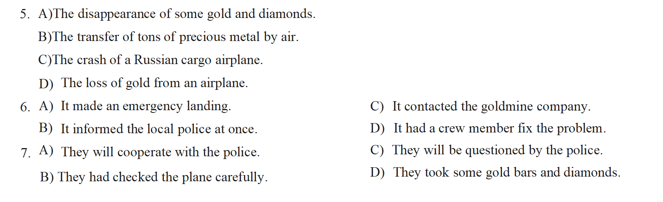



Section B

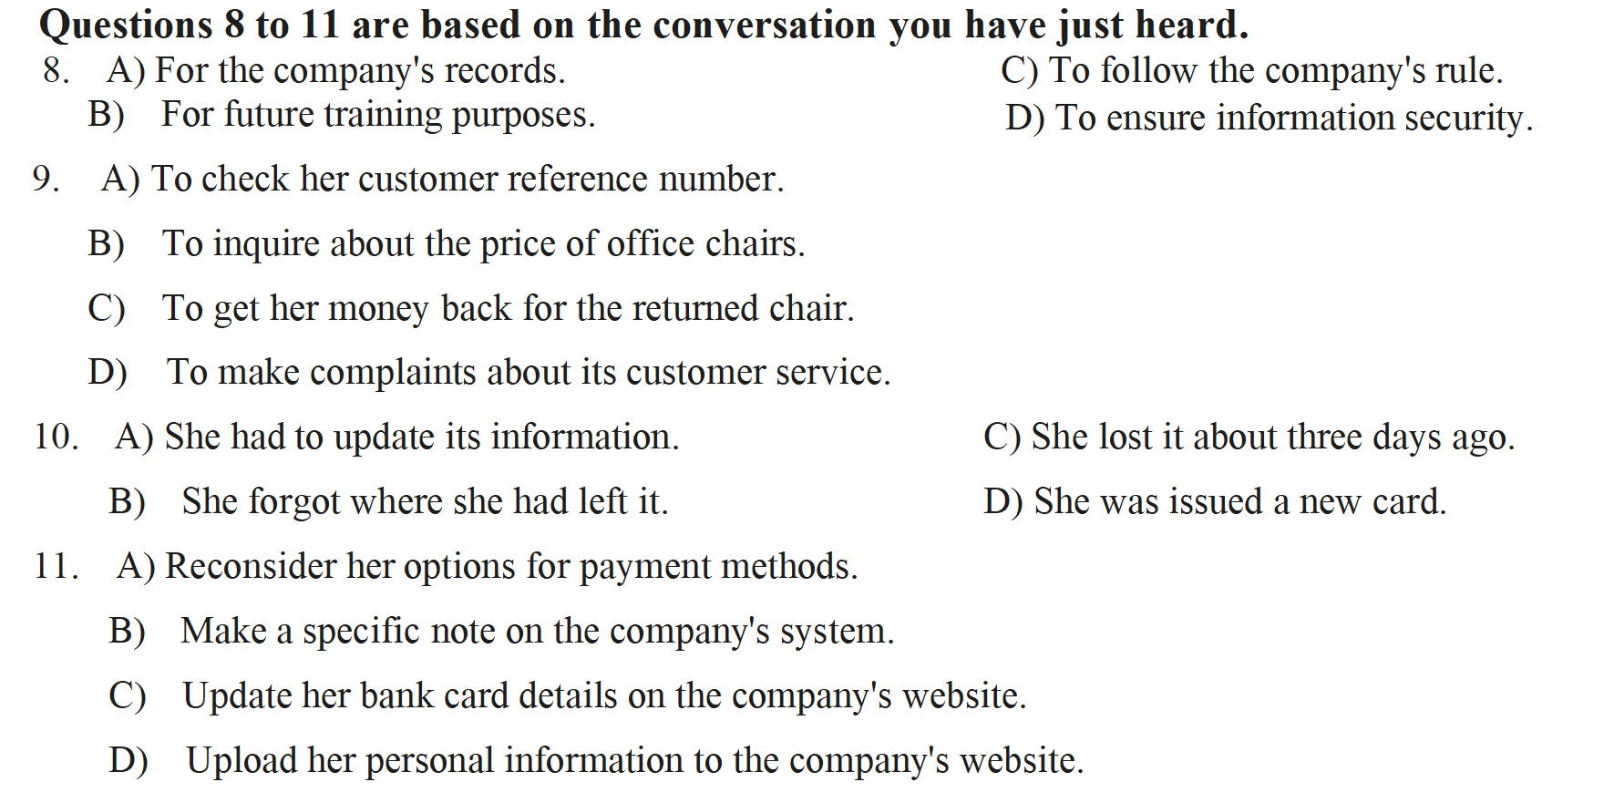

Questions 12 to 15 are based on the conversation you have just heard.

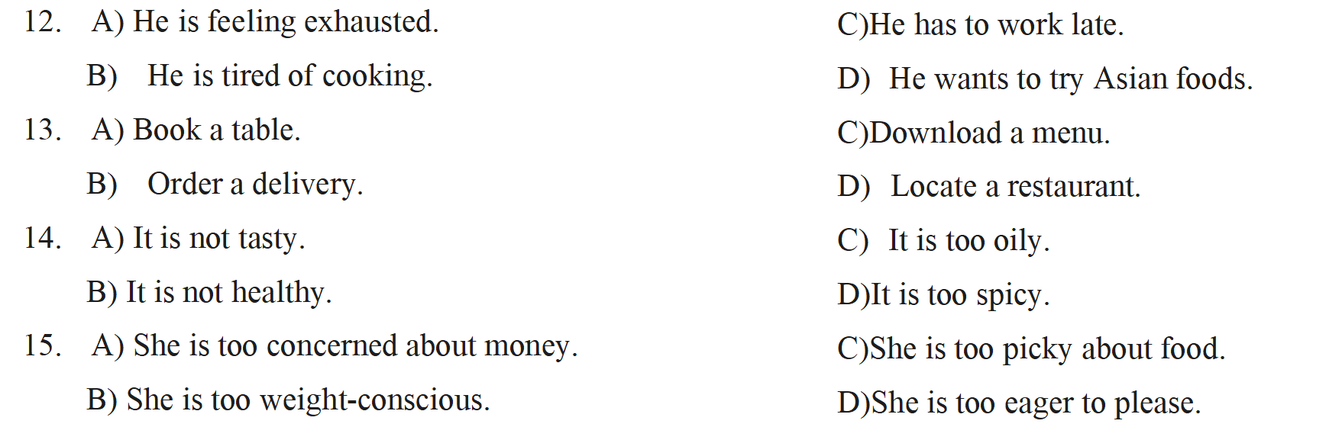

Section C

Questions 16 to 18 are based on the passage you have just heard.

16.A) Owners, personalities affect their cats’ behaviour and well-being.

B)Parents’ personalities can affect the personalities of their children.

C)Parents and cat owners alike experience high levels of anxiety.

D)More and more people are treating pet cats like their children.

17.A) Give their pets behavioral training. C) Know their pets’ feelings and desires.

B) Provide their pets with the best care. D) Interact with their pets in novel ways.

18.A) More convincing explanation. C) Collection of more data.

B) More extensive sampling. D) Further investigation.



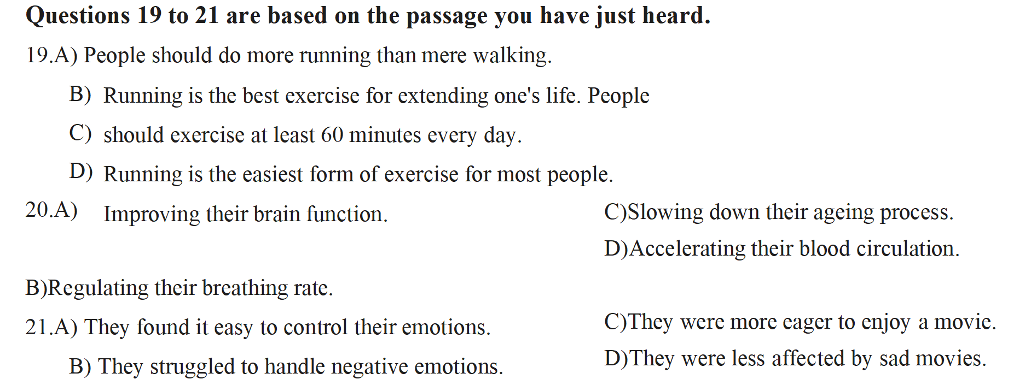

Questions 22 to 25 are based on the passage you have just heard.

22.A) He is a tour guide. C) He is a local entrepreneur.

B) He is a famous architect. D) He is the owner of the Hill House,

23.A) He studied the blueprints of other famous buildings.

B)He inquired about his client's family background.

C)He observed his client's life and habits.

D)He took a tour of his client's old home.

24.A) A house made of timber and brick. C) A house of the current fashion.

B) A house with a lot of free space. D) A house of a unique design.

25.A) They are well preserved and in pretty good shape.

B)They are copies built to the architect's designs.

C)They were designed by another architect.

D)They were badly damaged but restored.